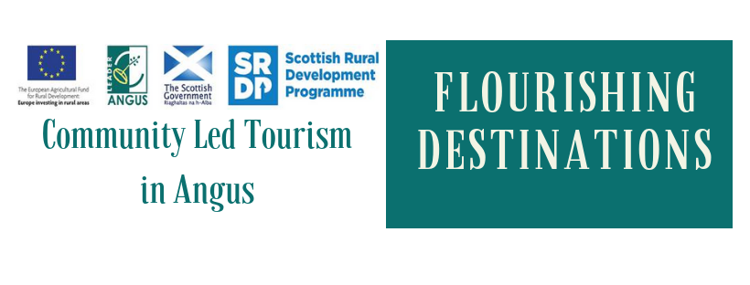

Exciting opportunity for individuals in Angus to take part in Belgium Learning Visit April 2020
Angus is currently taking part in a Transnational Cooperation Project with Belgium and Romania. This project aims to build the capacity of three areas in each country; Angus (SC), Meetjesland (BE) and Bazinul Dornelor (RO) to develop a flourishing visitor economy that benefits the whole community. Across the whole project we will be researching and driving community-led tourism using three main themes of welcoming visitors, promoting local food & drink and traditional rural skills.

We hope to engage with individuals, in all three countries, who are willing to work around a shared vision, purpose and set of values. We aim to promote learning and act collaboratively within our community. The work being carried out across three countries allows a rare opportunity to build and share knowledge of how a flourishing visitor economy can work.

What's involved in the learning visit?
Individuals will be able to attend a learning visit to Belgium in April 2020. One trip to Romania took place in March 2019 and Scotland hosted a visit in September 2019. These trips offer the opportunity to learn from like minded individuals in Europe, visit local enterprises and activities. Participants will come together in conversation to share lessons learned within their own region. Each trip will focus around three main themes of the project: welcoming visitors, promoting local food & drink and developing traditional rural skills.

Participants for these study tours should be enthusiastic individuals and/or key influencers for local tourism projects and should be committed to remaining engaged in this process and driving community-led tourism in Angus over the coming years. Following the learning visit, participating individuals must commit to sharing and disseminating their findings.
The first learning visit, to the Bazinul Dornelor region of Romania, took place from Monday 18th March to Saturday 23rd March 2019. Scotland hosted the Belgian and Romanian groups in September 2019. The final learning visit to Belgium will take place from Tuesday 21st April to Saturday 25th April 2020.

What does it cost?
Travel and accommodation is paid for through the projects. All other costs, including food, are at the participant’s own expense.

Who can take part?
The learning visits will be offered to individuals in the local community in Angus who are involved directly or indirectly in tourism. Participants can include individuals from businesses, community leaders or volunteers.

Eligible participants ideally must:
- Be over 18
- Have a personal drive to be a part of community-led tourism in Angus
- Have a love of rural
- Want to live and work in rural Angus
- Demonstrate that if he or she lives in urban areas, the benefit should go to the rural areas
- Be involved in tourism, community engagement or business entrepreneurship
- Demonstrate they have an interest in tourism, community engagement & business entrepreneurship if they are not currently active within one of these areas
- Be able to supply a letter of recommendation that confirms the individual has the character to participate.
- Be able to demonstrate their commitment to the development of tourism in Angus over the coming years.
- Have a passport

Being in employment at the time of application is not a criteria, as long as the individual can show their commitment to rural Angus.

The participant does not need to check all of the above criteria.

Participants will be required to commit to engaging with the project before the learning trip, agreeing targets, points of research and disseminating information on return to Angus. Key dates are listed below.

When and how to apply
To apply we ask that all applicants submit a covering letter (no more than 2 A4 sides) with C.V. This should be sent to flourish9norma@aol.com If a recommendation letter is required this will be requested during the selection process.

The deadline for applications to be submitted for Belgium visit is 20th December 2019. The project delivery partnership will meet to select, confirm and announce candidates by the 17th January 2020.

Key Dates for Applicants
All successful applicants for the Belgium 2020 trip must be available for the following dates.
March 2020 – 31st March. Learning Visit Planning Meeting 6.30 to 9.00pm. Applicants must be available to attend this meeting.
April 2020 - The learning trip is takes place from Tuesday 21st April to Saturday 25th April 2020.
May 2020 – 7th May. Learning Visit Debrief Meeting 6.30 to 9.00pm. Applicants must be available to attend this meeting

This project is being delivered by a project partnership consisting of Murton Trust, Angus Tourism Cooperative, Flourish9 and Angus Council. Any of the partners can be contacted for more information.

